#task 2 PREDICTION USING UNSUPERVISED ML

#in the 'Iris' dataset, predict the optimum number of clusters

#its visual representation

dt<-read.csv("iris.csv")

dt

head(dt)

#getting the type of variables

str(dt)

#summary of the iris dataset

summary(dt)

#using K-means for clustering data

data<-dt[2:5]

str(data)

plot(data,main="the width and length of petal and sepal",pch = 20,cex = 2)

#calculating the optimum number of clusters

wssplot <- function(data, nc=15, seed=1234){

wss <- (nrow(data)-1)*sum(apply(data,2,var))

for (i in 2:nc){

set.seed(seed)

wss[i] <- sum(kmeans(data, centers=i)$withinss)}

plot(1:nc, wss, type="b", xlab="Number of Clusters",

ylab="Within groups sum of squares")

wss

}

wssplot(data)

plot(x=1:15,col="blue",y=tot_wss,type="b",

xlab = "Number of clusters",

ylab = "within groups sum of squares")

#by graph, we interpret that optimum number of clusters because

#line changes immediately after cluster 2

#perform K-means with 2 clusters

km1 = kmeans(data,2,nstart = 100)

print(km1)

plot(data,col=(km1$cluster),main="K-means result with 2 clusters",pch=20,cex=2)

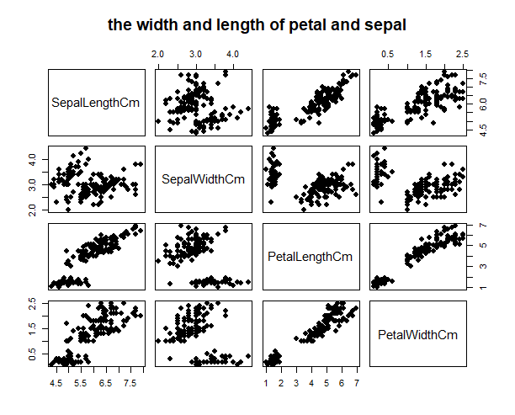

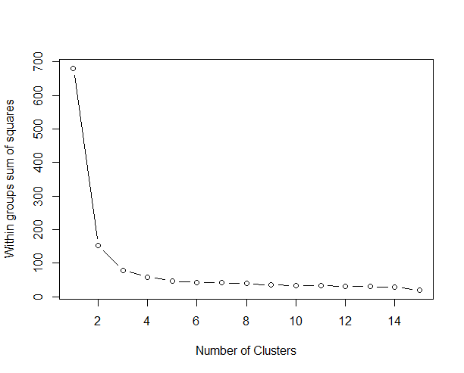

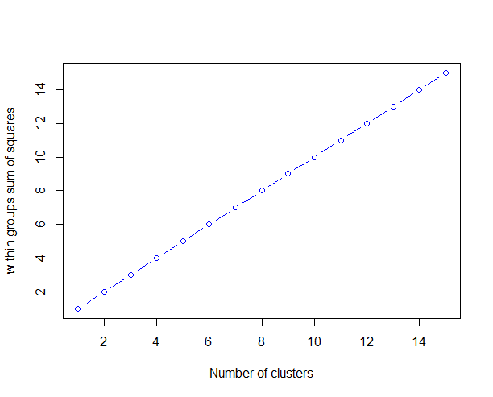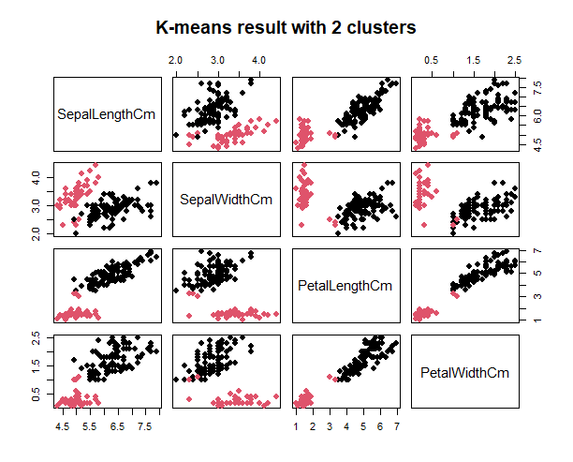

|  |
| --- |
| > #task 2 PREDICTION USING UNSUPERVISED ML  > #in the 'Iris' dataset, predict the optimum number of clusters  > #its visual representation  > dt<-read.csv("iris.csv")  > dt  Id SepalLengthCm SepalWidthCm PetalLengthCm PetalWidthCm Species  1 1 5.1 3.5 1.4 0.2 Iris-setosa  2 2 4.9 3.0 1.4 0.2 Iris-setosa  3 3 4.7 3.2 1.3 0.2 Iris-setosa  4 4 4.6 3.1 1.5 0.2 Iris-setosa  5 5 5.0 3.6 1.4 0.2 Iris-setosa  6 6 5.4 3.9 1.7 0.4 Iris-setosa  7 7 4.6 3.4 1.4 0.3 Iris-setosa  8 8 5.0 3.4 1.5 0.2 Iris-setosa  9 9 4.4 2.9 1.4 0.2 Iris-setosa  10 10 4.9 3.1 1.5 0.1 Iris-setosa  11 11 5.4 3.7 1.5 0.2 Iris-setosa  12 12 4.8 3.4 1.6 0.2 Iris-setosa  13 13 4.8 3.0 1.4 0.1 Iris-setosa  14 14 4.3 3.0 1.1 0.1 Iris-setosa  15 15 5.8 4.0 1.2 0.2 Iris-setosa  16 16 5.7 4.4 1.5 0.4 Iris-setosa  17 17 5.4 3.9 1.3 0.4 Iris-setosa  18 18 5.1 3.5 1.4 0.3 Iris-setosa  19 19 5.7 3.8 1.7 0.3 Iris-setosa  20 20 5.1 3.8 1.5 0.3 Iris-setosa  21 21 5.4 3.4 1.7 0.2 Iris-setosa  22 22 5.1 3.7 1.5 0.4 Iris-setosa  23 23 4.6 3.6 1.0 0.2 Iris-setosa  24 24 5.1 3.3 1.7 0.5 Iris-setosa  25 25 4.8 3.4 1.9 0.2 Iris-setosa  26 26 5.0 3.0 1.6 0.2 Iris-setosa  27 27 5.0 3.4 1.6 0.4 Iris-setosa  28 28 5.2 3.5 1.5 0.2 Iris-setosa  29 29 5.2 3.4 1.4 0.2 Iris-setosa  30 30 4.7 3.2 1.6 0.2 Iris-setosa  31 31 4.8 3.1 1.6 0.2 Iris-setosa  32 32 5.4 3.4 1.5 0.4 Iris-setosa  33 33 5.2 4.1 1.5 0.1 Iris-setosa  34 34 5.5 4.2 1.4 0.2 Iris-setosa  35 35 4.9 3.1 1.5 0.1 Iris-setosa  36 36 5.0 3.2 1.2 0.2 Iris-setosa  37 37 5.5 3.5 1.3 0.2 Iris-setosa  38 38 4.9 3.1 1.5 0.1 Iris-setosa  39 39 4.4 3.0 1.3 0.2 Iris-setosa  40 40 5.1 3.4 1.5 0.2 Iris-setosa  41 41 5.0 3.5 1.3 0.3 Iris-setosa  42 42 4.5 2.3 1.3 0.3 Iris-setosa  43 43 4.4 3.2 1.3 0.2 Iris-setosa  44 44 5.0 3.5 1.6 0.6 Iris-setosa  45 45 5.1 3.8 1.9 0.4 Iris-setosa  46 46 4.8 3.0 1.4 0.3 Iris-setosa  47 47 5.1 3.8 1.6 0.2 Iris-setosa  48 48 4.6 3.2 1.4 0.2 Iris-setosa  49 49 5.3 3.7 1.5 0.2 Iris-setosa  50 50 5.0 3.3 1.4 0.2 Iris-versicolor  51 51 7.0 3.2 4.7 1.4 Iris-versicolor  52 52 6.4 3.2 4.5 1.5 Iris-versicolor  53 53 6.9 3.1 4.9 1.5 Iris-versicolor  54 54 5.5 2.3 4.0 1.3 Iris-versicolor  55 55 6.5 2.8 4.6 1.5 Iris-versicolor  56 56 5.7 2.8 4.5 1.3 Iris-versicolor  57 57 6.3 3.3 4.7 1.6 Iris-versicolor  58 58 4.9 2.4 3.3 1.0 Iris-versicolor  59 59 6.6 2.9 4.6 1.3 Iris-versicolor  60 60 5.2 2.7 3.9 1.4 Iris-versicolor  61 61 5.0 2.0 3.5 1.0 Iris-versicolor  62 62 5.9 3.0 4.2 1.5 Iris-versicolor  63 63 6.0 2.2 4.0 1.0 Iris-versicolor  64 64 6.1 2.9 4.7 1.4 Iris-versicolor  65 65 5.6 2.9 3.6 1.3 Iris-versicolor  66 66 6.7 3.1 4.4 1.4 Iris-versicolor  67 67 5.6 3.0 4.5 1.5 Iris-versicolor  68 68 5.8 2.7 4.1 1.0 Iris-versicolor  69 69 6.2 2.2 4.5 1.5 Iris-versicolor  70 70 5.6 2.5 3.9 1.1 Iris-versicolor  71 71 5.9 3.2 4.8 1.8 Iris-versicolor  72 72 6.1 2.8 4.0 1.3 Iris-versicolor  73 73 6.3 2.5 4.9 1.5 Iris-versicolor  74 74 6.1 2.8 4.7 1.2 Iris-versicolor  75 75 6.4 2.9 4.3 1.3 Iris-versicolor  76 76 6.6 3.0 4.4 1.4 Iris-versicolor  77 77 6.8 2.8 4.8 1.4 Iris-versicolor  78 78 6.7 3.0 5.0 1.7 Iris-versicolor  79 79 6.0 2.9 4.5 1.5 Iris-versicolor  80 80 5.7 2.6 3.5 1.0 Iris-versicolor  81 81 5.5 2.4 3.8 1.1 Iris-versicolor  82 82 5.5 2.4 3.7 1.0 Iris-versicolor  83 83 5.8 2.7 3.9 1.2 Iris-versicolor  84 84 6.0 2.7 5.1 1.6 Iris-versicolor  85 85 5.4 3.0 4.5 1.5 Iris-versicolor  86 86 6.0 3.4 4.5 1.6 Iris-versicolor  87 87 6.7 3.1 4.7 1.5 Iris-versicolor  88 88 6.3 2.3 4.4 1.3 Iris-versicolor  89 89 5.6 3.0 4.1 1.3 Iris-versicolor  90 90 5.5 2.5 4.0 1.3 Iris-versicolor  91 91 5.5 2.6 4.4 1.2 Iris-versicolor  92 92 6.1 3.0 4.6 1.4 Iris-versicolor  93 93 5.8 2.6 4.0 1.2 Iris-versicolor  94 94 5.0 2.3 3.3 1.0 Iris-versicolor  95 95 5.6 2.7 4.2 1.3 Iris-versicolor  96 96 5.7 3.0 4.2 1.2 Iris-versicolor  97 97 5.7 2.9 4.2 1.3 Iris-versicolor  98 98 6.2 2.9 4.3 1.3 Iris-versicolor  99 99 5.1 2.5 3.0 1.1 Iris-versicolor  100 100 5.7 2.8 4.1 1.3 Iris-virginica  101 101 6.3 3.3 6.0 2.5 Iris-virginica  102 102 5.8 2.7 5.1 1.9 Iris-virginica  103 103 7.1 3.0 5.9 2.1 Iris-virginica  104 104 6.3 2.9 5.6 1.8 Iris-virginica  105 105 6.5 3.0 5.8 2.2 Iris-virginica  106 106 7.6 3.0 6.6 2.1 Iris-virginica  107 107 4.9 2.5 4.5 1.7 Iris-virginica  108 108 7.3 2.9 6.3 1.8 Iris-virginica  109 109 6.7 2.5 5.8 1.8 Iris-virginica  110 110 7.2 3.6 6.1 2.5 Iris-virginica  111 111 6.5 3.2 5.1 2.0 Iris-virginica  112 112 6.4 2.7 5.3 1.9 Iris-virginica  113 113 6.8 3.0 5.5 2.1 Iris-virginica  114 114 5.7 2.5 5.0 2.0 Iris-virginica  115 115 5.8 2.8 5.1 2.4 Iris-virginica  116 116 6.4 3.2 5.3 2.3 Iris-virginica  117 117 6.5 3.0 5.5 1.8 Iris-virginica  118 118 7.7 3.8 6.7 2.2 Iris-virginica  119 119 7.7 2.6 6.9 2.3 Iris-virginica  120 120 6.0 2.2 5.0 1.5 Iris-virginica  121 121 6.9 3.2 5.7 2.3 Iris-virginica  122 122 5.6 2.8 4.9 2.0 Iris-virginica  123 123 7.7 2.8 6.7 2.0 Iris-virginica  124 124 6.3 2.7 4.9 1.8 Iris-virginica  125 125 6.7 3.3 5.7 2.1 Iris-virginica  126 126 7.2 3.2 6.0 1.8 Iris-virginica  127 127 6.2 2.8 4.8 1.8 Iris-virginica  128 128 6.1 3.0 4.9 1.8 Iris-virginica  129 129 6.4 2.8 5.6 2.1 Iris-virginica  130 130 7.2 3.0 5.8 1.6 Iris-virginica  131 131 7.4 2.8 6.1 1.9 Iris-virginica  132 132 7.9 3.8 6.4 2.0 Iris-virginica  133 133 6.4 2.8 5.6 2.2 Iris-virginica  134 134 6.3 2.8 5.1 1.5 Iris-virginica  135 135 6.1 2.6 5.6 1.4 Iris-virginica  136 136 7.7 3.0 6.1 2.3 Iris-virginica  137 137 6.3 3.4 5.6 2.4 Iris-virginica  138 138 6.4 3.1 5.5 1.8 Iris-virginica  139 139 6.0 3.0 4.8 1.8 Iris-virginica  140 140 6.9 3.1 5.4 2.1 Iris-virginica  141 141 6.7 3.1 5.6 2.4 Iris-virginica  142 142 6.9 3.1 5.1 2.3 Iris-virginica  143 143 5.8 2.7 5.1 1.9 Iris-virginica  144 144 6.8 3.2 5.9 2.3 Iris-virginica  145 145 6.7 3.3 5.7 2.5 Iris-virginica  146 146 6.7 3.0 5.2 2.3 Iris-virginica  147 147 6.3 2.5 5.0 1.9 Iris-virginica  148 148 6.5 3.0 5.2 2.0 Iris-virginica  149 149 6.2 3.4 5.4 2.3 Iris-virginica  150 150 5.9 3.0 5.1 1.8 Iris-virginica  > head(dt)  Id SepalLengthCm SepalWidthCm PetalLengthCm PetalWidthCm Species  1 1 5.1 3.5 1.4 0.2 Iris-setosa  2 2 4.9 3.0 1.4 0.2 Iris-setosa  3 3 4.7 3.2 1.3 0.2 Iris-setosa  4 4 4.6 3.1 1.5 0.2 Iris-setosa  5 5 5.0 3.6 1.4 0.2 Iris-setosa  6 6 5.4 3.9 1.7 0.4 Iris-setosa  > #getting the type of variables  > str(dt)  'data.frame': 150 obs. of 6 variables:  $ Id : int 1 2 3 4 5 6 7 8 9 10 ...  $ SepalLengthCm: num 5.1 4.9 4.7 4.6 5 5.4 4.6 5 4.4 4.9 ...  $ SepalWidthCm : num 3.5 3 3.2 3.1 3.6 3.9 3.4 3.4 2.9 3.1 ...  $ PetalLengthCm: num 1.4 1.4 1.3 1.5 1.4 1.7 1.4 1.5 1.4 1.5 ...  $ PetalWidthCm : num 0.2 0.2 0.2 0.2 0.2 0.4 0.3 0.2 0.2 0.1 ...  $ Species : chr "Iris-setosa" "Iris-setosa" "Iris-setosa" "Iris-setosa" ...  > #summary of the iris dataset  > summary(dt)  Id SepalLengthCm SepalWidthCm PetalLengthCm PetalWidthCm  Min. : 1.00 Min. :4.300 Min. :2.000 Min. :1.000 Min. :0.100  1st Qu.: 38.25 1st Qu.:5.100 1st Qu.:2.800 1st Qu.:1.600 1st Qu.:0.300  Median : 75.50 Median :5.800 Median :3.000 Median :4.350 Median :1.300  Mean : 75.50 Mean :5.843 Mean :3.054 Mean :3.759 Mean :1.199  3rd Qu.:112.75 3rd Qu.:6.400 3rd Qu.:3.300 3rd Qu.:5.100 3rd Qu.:1.800  Max. :150.00 Max. :7.900 Max. :4.400 Max. :6.900 Max. :2.500  Species  Length:150  Class :character  Mode :character        > #using K-means for clustering data  > data<-dt[2:5]  > str(data)  'data.frame': 150 obs. of 4 variables:  $ SepalLengthCm: num 5.1 4.9 4.7 4.6 5 5.4 4.6 5 4.4 4.9 ...  $ SepalWidthCm : num 3.5 3 3.2 3.1 3.6 3.9 3.4 3.4 2.9 3.1 ...  $ PetalLengthCm: num 1.4 1.4 1.3 1.5 1.4 1.7 1.4 1.5 1.4 1.5 ...  $ PetalWidthCm : num 0.2 0.2 0.2 0.2 0.2 0.4 0.3 0.2 0.2 0.1 ...  > plot(data,main="the width and length of petal and sepal",pch = 20,cex = 2)  > #calculating the optimum number of clusters  > wssplot <- function(data, nc=15, seed=1234){  + wss <- (nrow(data)-1)*sum(apply(data,2,var))  + for (i in 2:nc){  + set.seed(seed)  + wss[i] <- sum(kmeans(data, centers=i)$withinss)}  + plot(1:nc, wss, type="b", xlab="Number of Clusters",  + ylab="Within groups sum of squares")  + wss  + }  > wssplot(data)  [1] 680.82440 152.36871 78.94084 57.35502 46.55057 41.79382 40.74987 39.12050  [9] 34.29131 33.49303 32.62466 30.80300 29.43299 27.10884 19.50422  > plot(x=1:15,col="blue",y=tot_wss,type="b",  + xlab = "Number of clusters",  + ylab = "within groups sum of squares")  > plot(data,col=(km1$cluster),main="K-means result with 2 clusters",pch=20,cex=2) |
|  |
| |  | | --- | | > | |